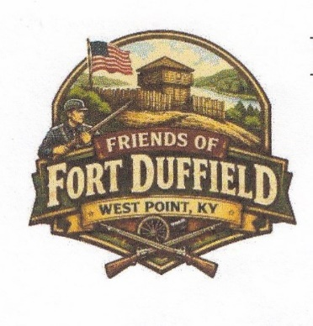
Fort Hill Park
Historic Site of
Fort Duffield
Circa 1861

They Shall Not Be Forgotten

A gift to the City of West Point from the Secretary of the Interior, United States Government, the park was officially transferred on January 18, 1974.
Open 6 AM to 8 PM
Gate at River Rd and Fort Duffield Rd (aka- Honeysuckle Rd) will be locked!

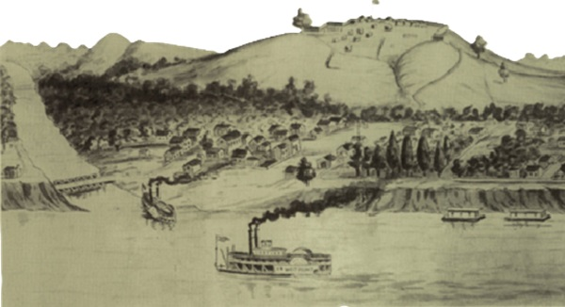
Please protect our Natural Resources

